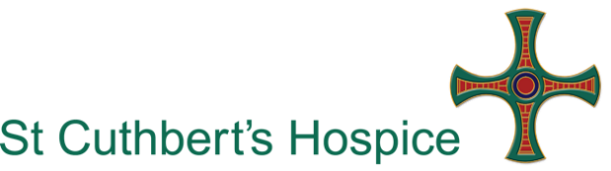
Day Services Minibus Driver
Volunteer Role Description

What is a Day Services Minibus Driver?

The Day Services Minibus Driver is responsible to the Day Services Manager. They provide a safe transport service to and from the Hospice for our patients (guests).

This role will suit people who are…

- Friendly and helpful
- Honest and reliable
- Able to work alone or as part of a team

It is also essential that you can demonstrate our values of Compassion, Respect, Integrity, Professionalism, Choice and Reputation. They define who we are and what we do as a high quality care provider and high quality place to volunteer.

Why do we need you?

We are looking for volunteers to support our Living Well Centre and its guests in providing safe transportation to and from the Hospice and running errands for the clinical team. The support you provide will allow us to effectively support people to live well with life-limiting conditions.

What’s involved?

- Transporting guests to and from the Hospice in a safe and timely manner
- Undertaking Minibus Driver Awareness Scheme (MiDAS) training
- Assisting guests on and off the minibus
- Ensuring that guests are fastened into the minibus correctly and securely in accordance with MiDAS training
- Maintaining the comfort and safety of guests being transported
- Taking into account a patient’s individual needs and offer assistance as required. This may include the transportation of oxygen and mobility equipment
- Completing the vehicle checklist prior to each use to ensure the vehicle conforms to all legal and safety requirements
- Reporting any faults with the vehicle to the Day Services Manager
- Providing proof of current and up to date driving licence
- Adhering to all health and safety and infection control policies; including the use of personal protective equipment (PPE) as appropriate and as instructed
- Keeping accurate records of journeys and mileage undertaken

What should you already have and what could you gain from this opportunity?

You must be aged 25 or over

You should have:
- A full clean driving licence
- Minimum of 1 years driving experience
- A sound understanding of the importance of maintain confidentiality

The Hospice will provide you with any necessary information regarding the guests who use our Living Well Centre. Full guidance and support will be given to give you an understanding of how to manage an emergency situation. MiDAS training will be provided by the Hospice.

What you could gain:

From this role you can gain experience of minibus driving and basic patient care. You can also gain an awareness of Hospice care and the care that we provide at St Cuthbert’s Hospice.

You will have the opportunity to meet new people and become part of a friendly, caring team.

Policies and Procedures

As a volunteer you will be expected to comply with Hospice Policies and Procedures relevant to your role and to maintain confidentiality.

Out of pocket expenses

Any agreed out of pocket expenses that are incurred when carrying out your volunteer role will be reimbursed.

A Disclosure and Barring Service (DBS) check is required for this volunteer role

Extra Information
Your availability
Monday – Friday at varying times. To be discussed with the Day Services Manager

Location
You will start and finish your day at St Cuthbert’s Hospice, Park House Road, Durham, DH1 3QF with travel to and from our guests homes in the Durham area.

Training
We value our volunteers and want your experience to be both positive and fulfilling. We offer a comprehensive induction programme and any appropriate instruction, guidance or training to assist you in your volunteer role. We ask that any essential training is completed either prior to you starting with us or within three months of starting. You will have an opportunity to learn new skills, build social networks, share experiences and skills and be recognised for the contribution you make.

Who to contact
For more information regarding this volunteer role please contact (0191) 3746169 or volunteers@stcuthbertshospice.com

